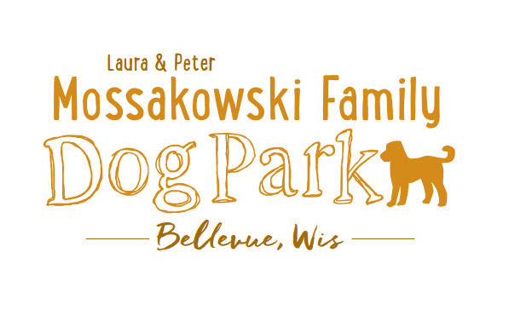
Laura and Peter Mossakowski Family Dog Park, LTD Committee Meeting
Date & Location: March 29, 2017 9:30am-11:30am; at Laura Mossakowski LLC (2555 Continental Dr.; Green Bay, 54311)
Meeting Began: 9:30am
In attendance: Paul Theys, Laura Mossakowski, Stephanie Schlag, Jennie Wertel, Peggy Grimmer, Sandy Kemper, Mark Schuster
Secretary Report:
Approval of March 1st, 2017 minutes – Paul, Laura
Treasurers Report:
Current Balance: $11,023.89
Outstanding Bills: credit card bill to be paid yet, Liser still owed $10,500, Bulletin Board (much was covered by donation)
Incoming Donations: some added this morning and more to add that just came in
Community Fundraising:
K9 Karnival and Grand Opening major projects at this time
Grant Writing – need volunteers to help (UWGB, NWTC, or other college to help with grant writing as a part of a college course/project/internship) – updates? – still looking to see if there are options for outside help
Green Bay Bullfrog Baseball Fundraiser night – two options of “packages” that are available for fundraising
Old Business:
Looking at options for donor signs – many options need sign approval and will need to be uniform with other signage in the park and other parks – Guidelines needed from the Village and details about getting official approval, initial quote and mock up being looked at
Membership Stickers Ordered – sales start at K9 Karnival (600 stickers ordered) – registration done through village, Jerry’s Auto Body and Sales to donate the WiFi hot spot and someone is needed for taking the funds for the registration
Volunteer Committee Updates: Volunteers needed to help with recruiting; no age limit, forms just ask for an adult to sign the waiver – for both the K9 Karnival and the Park, more individuals are needed for a booth at the park as well (at least 10-15 additional volunteers needed for the Karnival) – call out on SM for help as well as FOB link to it
K9 Karnival Planning: (May 13th from 10am-2pm)
Raffle items / list of donors – Packer item TBD, continue to go through list for donations and raffle items, bring all raffle items to Laura’s office for assembly
Volunteer Table added to Karnival Layout - include "titles/roles" that are needed (Grant writers, etc.)
MC - Alexi
Poss. Live Music
Booth coordination – Sandy
Station for credit card for Paul to be at (large sign needed)
Phone list updated for communication at event
Raffle workers - Paul, Laura, and one needed
Pictures & Info Booth - Jennie
Volunteer Table - Nicole
Posters/Fliers – Stephanie
Bounce House – Adam to reach out to Salvation Army
Luer Course – Mark to run it with 2-3 more to help (Angela?)
Food Booth – Steve and family? And friends of Bellevue members?
Steve to see if food donations are an option from businesses?

Morning meeting at the day of the Karnival to meet all volunteers, get name tags, and see/hear job duties – Set-up starting at 8:30, brief meeting for volunteers at 9:30

Vendor Booths – Vendors should not be selling food/beverages, but is other fundraising OK?
Booth rental fee of $25, table rental fee of $10, NPO’s leave $25 deposit and can get it back upon check-in (approved 3/1/17)
$5 donation per dog attending and 5 event tickets per family
Festival to join us with cart – Laura to ask PR individual she has been talking to
Look to get help with fund counting post event from the bank or others – Denmark State Bank allowing us to borrow a currency counter for the day
Grand Opening Planning: Date TBD (ideally within a few weeks of K9 Karnival)
Nicole to help head up the event?
Thoughts on activities?
Home Depot Employee Work Day - Landscaping is specialty for the projects, a Grant covers the cost of the items – need walkthrough for the company before starting
Ideally a 1-day project, need to do a walk-through - looking to do project around sign and driveway and around the fence where the trash bins are – Updates
If plantings are done do them early in spring to help with minimizing the need for watering. Suggest doing the screening around the garbage area and signage plantings
Donation Envelopes with tear-off – Stephanie looking to get options - Update

Nicole Virant nominated as Director of Marketing to the Dog Park Committee Board Feb. 1, 2017 – Acceptance needed from Nicole

*Addition of a Mission Statement for the Park – further thoughts/approval
Laura & Peter Mossakowski Family Dog Park (Bellevue Dog Park) is a volunteer-based, non-profit501(c)(3) organization. The Bellevue Dog Park Committee is dedicated to providing an off-leash dog park where dogs and their owners/friends have a safe, well-maintained area for recreation and socialization.
The Bellevue Dog Park committee will also make it their focus to educate children about safe behavior around dogs to ensure a common goal of safety and fun for all.
The Bellevue Dog Park relies on local and private funding to continue growth and development of this off-leash dog park. The committee welcomes collaboration with residents, businesses, municipalities, and non-profit groups to work toward this common goal.

Obtain Bulletin Board with plexi-glass coverings – Lions Club approved sponsorship

Child Safety Program Update (Sandy)

Next Meeting Dates:
No further VB meetings set for Dog Park related items
Next committee meetings: April 14th 9am @ LMLLC; April 26th 9:15am @ LMLLC; May 10th 9:15am @ LMLLC
Construction Updates:
Still looking for nature to tell us when the grass can be mowed to allow further planning for opening dates
New Business:
Wix Memorial Update
Marketing Recruitment Ideas - Social Media plugs for upcoming events and volunteer needs (Nicole), any other thoughts/suggestions?
Volunteer Agreement – Customize it for the Dog Park
Logging options for hours for volunteering through the year - potential to earn discounts off of future passes, appreciation brunch etc. – Further Thoughts
Donation from Kathy Ploeckelmann – Trees, Concrete Bench – thoughts/suggestions?
Eagle Scout Project – Connor L. – Bench or other item to help provide for the park
Additional Work Day needed shortly after K9 Karnival (tentative date: June 3rd) – install more trees (spruce trees and 18 from village), install message board sign, post signs, prepare park for Grand Opening, general clean up, cement slabs for benches, coincide with Home Depot Employee Work Day
Meeting Adjourned: 11:30am

Topics for Next Meeting:
Memorial Bench standard options and costs for those interested in donation

